Jose Flores
11/21/2025
Assignement: Module – 5.2

Value Stream Mapping (VSM)

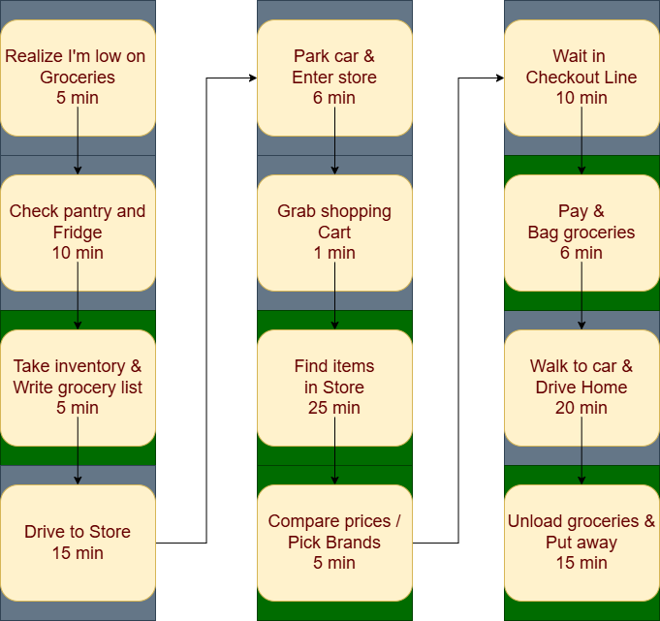

Current-State Grocery Shopping
- Total time: About 2 hours (123 minutes)
- Time spent on useful tasks: 56 minutes (~45%)
- Time wasted: 67 minutes (~55%)
Where time is wasted
- Driving to and from the store: 35 minutes
- Waiting in line: 10 minutes
- Extra small tasks: 16 minutes (checking pantry, parking, walking in/out of store, grabbing a cart)
Future-State / How to Make it Better
- Order online or use curbside pickup → Skip driving, parking, and waiting in line. This could save about 50 minutes.
- Plan meals and use a pantry list → Check what you need ahead of time so you don’t spend extra minutes checking shelves. Save ~10–15 minutes.
- Bring a ready-made shopping list → Find items faster in the store. Save another 10–15 minutes.
Result:
- Total shopping time could drop to 50–60 minutes
- More time would be spent on useful tasks (~70–80%)
- Overall, it’s quicker, simpler, and less stressful.

